**Font:** Roboto

# **LOGIN PAGE**

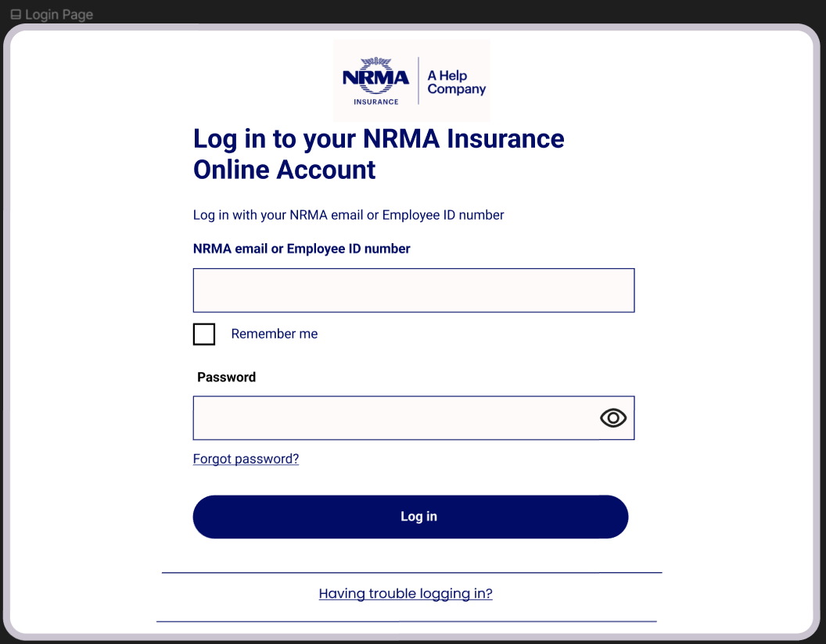

## **Colour Hex:**

**Font Colour:** 010c66 or FFFFFF

**Text Blue Box Colour:** 010C66

**Text Blue Box Border Colour:** 010C66

**Grey colour for most buttons:** FDFAF9

**White Background:** FFFFFF

**Email/Password box:** FDFAF9

**Email/Password box when hovering:** ECF0F6

**Login Blue Button Colour when hovering:** 00084E

## **Functionality:**

This page is the ‘login page’ where the claims officer will access the fraud detection system by entering their NRMA email address or Employee ID number and a secure password.

This is necessary due to the existence of high risk information, such as PII in the system, to ensure that all data is handled by qualified personnel.

* When the boxes to enter data is hovered over/clicked on the colour changed to ECF0F6 and the thickness of the box border increases 3x
* Left of ‘remember me’ is a check box thus, need a tick after clicking
* The eye icon changes when clicked to ‘see password’ and ‘hide password’
* When ‘forgot password’ and ‘having trouble logging in?’ is hovered the text is highlighted with ECF0F6

# **HOME/LANDING PAGE**

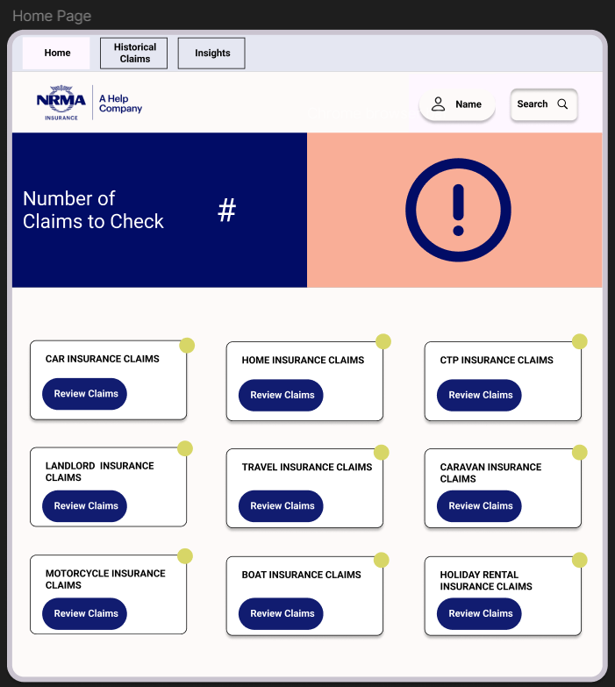

**Colour Hex:**

**Font Colour:** 010c66

**Background Colour:** FDFAF9

**Top Grey Bar:** E5E7F2

**Top navigation box when on page:** FDFAF9

**Top navigation box when not on page:** E5E7F2

**Blue Button Colour:** 010C66

**Review Blue Button Colour when hovering/clicked:** 00084E

**Text box pink colour:** F9AE97

**Green Circle:** D7D667

**Search/Name button:** FDFAF9

**Search/Name button when hovering:** ECF0F6

## **Functionality:**

This page is the ‘home page’ where the claims officer will go when they login to the system.

* When the name and search buttons are hovered over/clicked on the colour changed to ECF0F6
* When the search button is clicked it opened up to show the space to write text 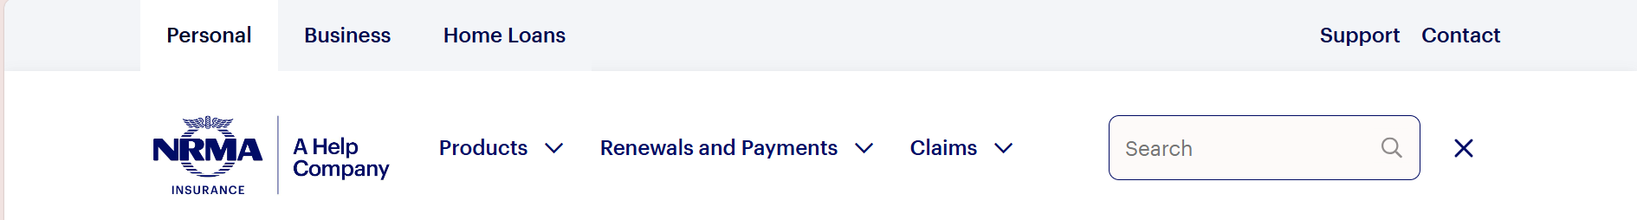
* Name button should have the claim officers name
* When the top navigation buttons are hovered over/clicked on the colour changed to FDFAF9 and when not in use the colour is E5E7F2
* The ‘#’ in for number of claims to check should be replaced with the number of pending claims in the database
* When the ‘Reveiw Claim’ buttons are hovered over/clicked on the colour changed to 00084E and when not in use the colour is 010C66
* Green circles show how many claims are there to review in each insurance category

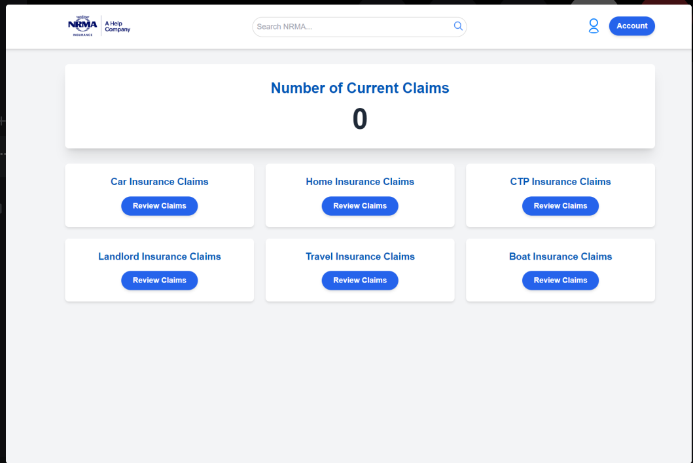

# **FRAUD DETETCTION PAGE**

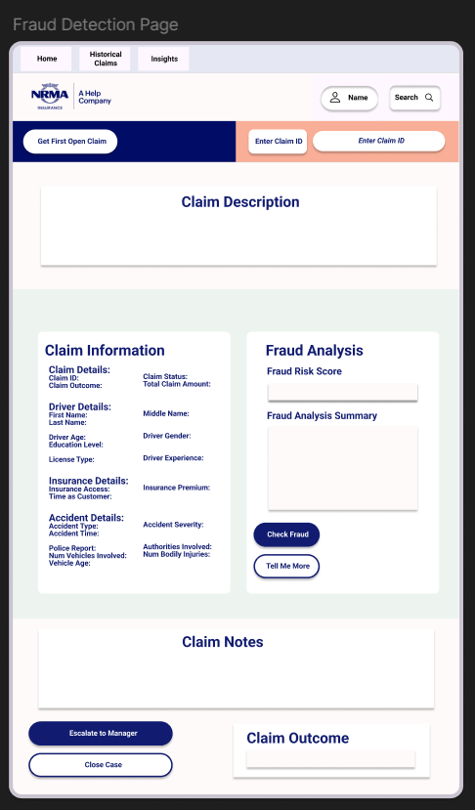

**Colour Hex:**

**Top Grey Bar**: E5E7F2

**Green Background behind:** EDF4F0

**White background colour:** FDFAF9

**Blue Button Colour:** 010C66

**Blue Button Colour when hovering/clicked:** 00084E

**White Button Colour:** FFFFFF

**White Buttons when hovering:** ECF0F6

**Text box pink colour:** F9AE97

**Font Colour:** 010C66

**Blank box under - fraud risk score/ summary/ claim outcome:** FDFAF9

**Search/Name button:** FDFAF9

**Search/Name button when hovering:** ECF0F6

## **Functionality:**

This page is the ‘Review Claims’ where the claims officer will go to review claims.

* When the name and search buttons are hovered over/clicked on the colour changed to ECF0F6
* When the search button is clicked it opened up to show the space to write text 
* Name button should have the claim officers name
* When the top navigation buttons are hovered over/clicked on the colour changed to FDFAF9 and when not in use the colour is E5E7F2
* When the blue buttons are hovered over/clicked on the colour changed to 00084E and when not in use the colour is 010C66
* When white buttons are hovered over/clicked on the colour changed to ECF0F6